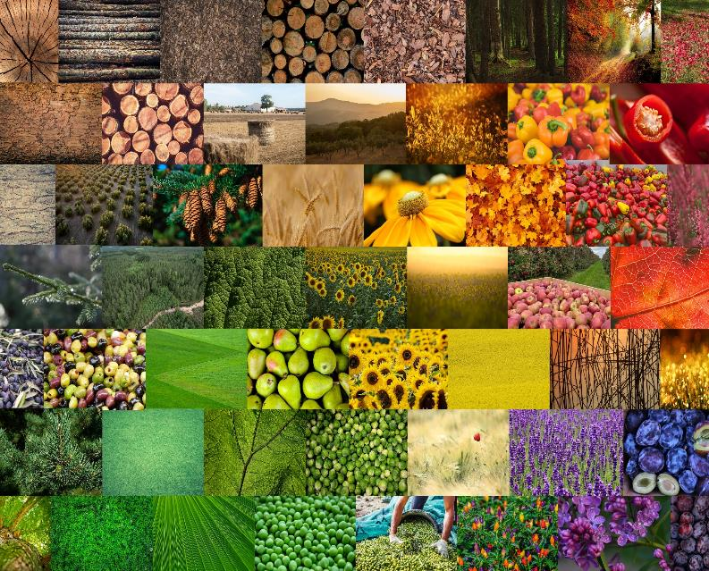



WS3 Training Programme Protocol

Proceedings of the training sessions in WS3

**Digitalisation in the Bioeconomy**

**Session #2: Harnessing AI systems and Drones for cutting-edge Innovation**

06 February 2024

**Session #2: Harnessing AI systems and Drones for cutting-edge Innovation**

The session titled "Elevating Biotechnology: Harnessing AI Systems and Drones for Cutting-edge Innovation" within the Digitalisation in the Bioeconomy workstream, focused on exploring the potential for rural actors in leveraging advanced technologies. The agenda included presentations on various aspects such as the role of drones, space technologies, AI, machine learning, and advanced robotics by Viktoria Motsch from the University of Applied Science in Upper Austria, as well as discussions on the role of bioinformatics in digitalized bioeconomy led by Martin Riegler from wood K plus. Case studies featuring the utilization of drones in agriculture for disease and pest detection by Mario Petkovski from AgFutura Technologies, and the digitalization of the Swedish National Forest Inventory by Jonas Fridman from the Swedish University of Agricultural Sciences, Umeå, were also included. Breakout sessions, facilitated in participants' languages, were scheduled to foster collective discussions addressing the specific needs and challenges in their respective regions. The session concluded with feedback on key outcomes from the breakout sessions, discussions on moving forward, and a short survey for participants to provide feedback on the training.

**BREAK-OUT ROOMS**

**UPPER AUSTRIA**

One challenge that was discussed in the group was the different levels of knowledge and use of digital tools. For instance bigger companies usually are very sophisticated in digital technologies whereas small businesses are often lacking behind. This is the view from research, where it is very hard to motivate small businesses to join research projects.  
Hurdles that hinder people from taking part in research or digitalization projects are bureaucracy and the image of projects being complicated. People who never took part in research often don`t know what the benefits are or are shy of participating. Often, people think that new technologies are very expensive, but a lot of technologies are so advanced, that they are already quite cheap: drones or 3D printer. Education also plays a role: participants at the InnovationHUB often have a background from technical education or university.

Drones are a big deal at the moment, most enquiries and consultations are about the use of drones and applications, but here the prices can be very high for special or individual solutions.   
At Wood Kplus, most enquiries are about Cobots, 3D printer and sensors (and about website creation and online shops).

One Example was given, where a company, selling herbs and spices, is setting incentives to their farmers to invest or use new technologies.

Adressing the topic of fundings, there are 2 outputs:

a) in Austria, there are very little funding sources for digitalization in agriculture. At the moment, there is nothing in Upper or Lower Austria (e.g. for drone search for fawns (deer) or GPS). What is needed is infrastructure funding on a low level.

b) on the other hand, funding for cooperative research is quite good.

Output: low level funding of infrastructure is needed to support digitalization in agriculture.

**NORTH MACEDONIA**

On national level, a diverse tools are being used to address various needs. However their usage is rather limited and not fully exploited. Artificial Intelligence, exemplified by ChatGPT, enhances data processing capabilities, facilitating efficient analysis and decision-making. Drones play a crucial role in sensoring and monitoring activities, providing valuable data for agriculture, security, and environmental assessments. Space technologies, including satellite images and resources like Sentinel-2, contribute significantly to mapping, disaster management, and environmental monitoring. Additionally in Strumica region, specialized equipment such as data logger intensitometers aids in measuring soil moisture levels is used, while weather stations offer real-time data for comprehensive environmental analysis.

The use of new technologies on national level as well as in Strumica region encounters various challenges. There are numerous apps, causing potential confusion about which ones to utilize. Awareness and knowledge about these tools are lacking among the population, with a particular hindrance being the low proficiency in English. The benefits of these technologies are not always evident due to the absence of demonstration farms or projects showcasing their practical applications. Financial support is limited, and when available, its utilization is often hindered by the small land parcels owned by individual farmers. To improve the situation, increased education and support are needed to enhance understanding and promote the effective use of these technologies.

Legal regulations for the integration of discussed tools are currently in the process of implementation, with the transposition of EU Regulations on drones in 2024 already underway in North Macedonia. Furthermore, a law specifically addressing drones was adopted in 2017, providing a legal framework for their use. These regulations are designed to support and regulate the incorporation of these tools into various activities, ensuring compliance and safety standards.

**POLAND**

What kind of technologies like AI, drones or space technologies are needed to be used in your region?

In the Mazovia region of Poland, agriculture is not yet embracing the use of modern technologies such as AI, drones, and space technologies to improve apple orchard production. AI could be used to analyse data and create predictive models that optimise orchard management practices, such as irrigation scheduling, pest control, and yield prediction. Drones equipped with cameras and sensors could be employed for aerial surveys to monitor plant health, detect disease outbreaks, and assess crop damage. Space technologies, such as satellite imagery and GPS, contribute to precision agriculture by providing real-time data on soil moisture levels, vegetation indices, and weather patterns, which helps farmers make informed decisions and enhance productivity, which could provide the farmers with important insights.

Despite the potential advantages of using new technologies in apple orchards in the Mazovia region, there are several challenges that hinder their broader adoption.

One of the main challenges is the high cost of purchasing and implementing these technologies, which can be too expensive for small-scale farmers.

Additionally, farmers may lack the necessary knowledge and expertise to understand the capabilities and integration of these technologies into their existing practices.

There are challenges related to data privacy and cybersecurity that can discourage farmers from using technology that involves sharing sensitive farming data. Additionally, limited access to reliable internet connectivity in rural areas can prevent the effective use of cloud-based AI platforms and remote monitoring systems.

Legal regulations exist for the use of AI, drones, and space technologies in agriculture, but their implementation is still ongoing. To facilitate the integration of these technologies into agricultural activities in the Mazovia region, a comprehensive legal framework is required. This framework should cover various aspects such as data ownership and sharing agreements, privacy protections, safety standards for drone operations, licensing and certification requirements for operators, and compliance with environmental regulations. Collaborative efforts involving government agencies, industry stakeholders, and academic institutions are crucial to developing and enforcing regulations that promote the responsible and sustainable use of these technologies while addressing the concerns of farmers and other stakeholders in the bioeconomy sector. The implementation of the AI Act at the European level should help clarify the situation in Poland.

**SPAIN**

The use of drone and AI technologies is justified in the Andalusian region from the point of view of optimizing processes and achieving sustainable and innovative agriculture. In this sense, several cases of possible uses were discussed during the session. Among them, it is necessary to highlight the following:

- The use of drones to reduce the use of pesticides in the field. Due to the use of certain algorithms, they can be used more selectively and not spraying the entire crop.

- Reduction of crop water stress. Using AI and a series of specific algorithms to create automated systems and predictive data models to improve supply chain services.

- Reduction of production costs by optimizing industrial processes.

- Bioinformatics as a key tool for the measurement of growing conditions, reduction of soil and water use, and development of hydroponic growing, among others.

However, the use of these technologies presents a number of challenges, the following have been identified during the session: Lack of knowledge and mistrust of this technology, especially due to lack of information. On the other hand, it was commented that the workforce in the field is too professionalized and "senior", which makes it difficult to access and understand this technology. Therefore, young people need to be attracted to work in the field.

The session raised the legislative issue as a source of unknown, as it is still very incipient and not well defined.

**FRANCE**

no french breakout room

**INTERNATIONAL**no international break out room

**Cross-regional conclusions/learnings**

**Challenges that hinder the utilization/purchasing of new technologies   
and the participation in research projects:**

* Lack of awareness and knowledge capabilities and integration of these technologies into their existing practices
* Mistrust of this technology
* Low proficiency in English
* absence of demonstration farms or projects showcasing their practical applications
* Confusion caused by a variety of applications with different options and possibilities
* Small farming structures
  + utilization is often hindered by the small land parcels owned by individual farmers
  + too expensive for small-scale farmers
* In general: people think that new technologies are very expensive
* Data privacy and cybersecurity issues are discouraging farmers
* Limited access to reliable internet connectivity in rural areas
* On the other hand, it was commented that the workforce in the field is too professionalized and "senior", which makes it difficult to access and understand this technology. Therefore, young people need to be attracted to work in the field.
* Extremely inhomogenous levels of knowledge and use of digital tools
* Bureaucracy and the image of projects being complicated hinder people from taking part in research projects
* Education also plays a role: project participants often have a background from technical education or university
* Regional lack of funding sources for digitalization in agriculture

**Participant feedback**

At the end of the training session, the participants were asked to fill in a short survey to evaluate the training session. In the end, 9 participants responded to the survey, of which 3 from Sweden, 2 from Poland, 1 from Spain, 1 from Austria, and 1 from Macedonia. Additionally, 1 participant answered the English survey and the optional question regarding their location was not answered. This gave the following results:

**Quality**

The participants were asked to rate the quality of the training session on a scale from 1 (poor) to 4 (excellent). Over half of the participants (5) responded with a 4, meaning they found the training session to be of excellent quality. The other 4 participants responded with a 3.

The participants were then asked what went well during the session. Multiple participants answered that they liked the contents, presentations and variety of speakers. Additionally, they complemented the process and automatic forwarding to the breakout rooms.

Next, the participants were asked what could have gone better. Here, there were multiple comments on the length of the presentations and the time management of the session. One of the participants responded that some of the presentations were too long and had too much information.

**Comparison to first session**

The next question was about how the second training session compared to the first session. Here, the participants said that they were equal, just as well and even better, as there were no technical issues. Additionally, one of the participants mentioned that they liked that there were new technologies presented.

**Understandability**

The participants were also asked whether the presentations were easy to follow. They were asked to rate this on a scale from 1(with difficulty) to 4 (easily). Out of the 9 participants, 5 gave this a score of 4 (easily), and 3 participants a score of 3, meaning that the presentations were relatively easy to understand.

**Topics**

When asked which topic was most interesting, we received the following answers:

• All of them

• Bioeconomy and new business models with AI

• Topics related to agriculture

• Forest inventory

• WoodK plus case study

**Field of occupation**

The survey concluded with an optional question regarding the participant’s field of occupation. The participants came from different areas; 3 from agriculture, 2 from forestry, 1 from research, 1 from an NGO, 1 from business administration, and 1 working in the bioeconomy.

**Participants:**

If you wish to get in touch with one of the participants from this session, please contact someone in the SCALE-UP consortium.

Cover page photos © BFR, CTA, UNIMOS, franceagritwittos.com, and pixabay.com